Risk Map
Risk Map (Probability vs Impact)
Scale
- Probability: 1 = Low, 3 = Medium, 5 = High
- Impact: 1 = Low, 3 = Medium, 5 = High
Risk Map Matrix
Impact \ Probability | 1-Low | 3-Medium | 5-High
5-High | Risk 4 | Risk 1 | -
3-Medium | Risk 2 | - | Risk 3
1-Low | - | - | -

Risk Interpretation
- Risk 1: Medium probability, high impact → High priority
- Risk 3: High probability, medium impact → High priority
- Risk 4: Low probability, high impact → Medium priority
- Risk 2: Low probability, medium impact → Low priority
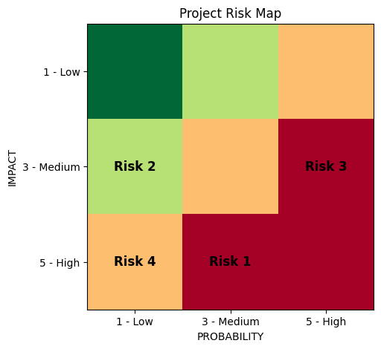
Figure 7 : Project Risk Map
Residual Risk Map (After Mitigation)
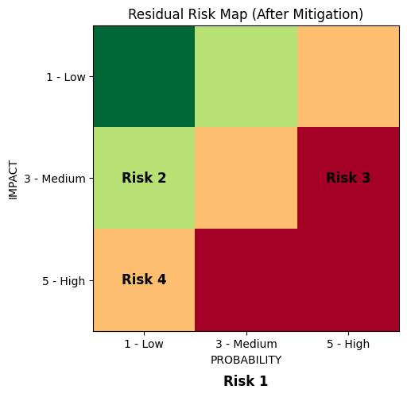
Figure 8 : Residual Risk Map Following Mitigation Actions
Residual Risk Interpretation
- High-risk items shift toward medium or low zones
- No risks remain in high–high category
- Residual risks are acceptable and manageable
Libre Project File
Submitting Project File by Uploading into google drive and also uploaded as separate file
Google Drive Link :
https://drive.google.com/file/d/1SOWRU30_s-hQoeUYB8OVG29X6y_ZgKNb/view?usp=drivesdk

References
- Chen, L.-C., Papandreou, G., Kokkinos, I., Murphy, K., & Yuille, A. L. (2018). DeepLab: Semantic image segmentation with deep convolutional nets, atrous convolution, and fully connected CRFs. IEEE Transactions on Pattern Analysis and Machine Intelligence, 40(4), 834–848.
https://doi.org/10.1109/TPAMI.2017.2699184
- Chen, L.-C., Zhu, Y., Papandreou, G., Schroff, F., & Adam, H. (2018). Encoder–decoder with atrous separable convolution for semantic image segmentation. In Proceedings of the European Conference on Computer Vision (ECCV) (pp. 801–818). Springer.
https://doi.org/10.1007/978-3-030-01234-2_49
- Donchyts, G., Schellekens, J., Winsemius, H., Eisemann, E., & van de Giesen, N. (2021). A global surface water dataset from 1999 to 2018 derived from Landsat imagery. Remote Sensing of Environment, 252, 112114.
- Escobar, F. (2020). Satellite images of water bodies (Version 1.0) [Data set]. Kaggle.
https://www.kaggle.com/datasets/franciscoescobar/satellite-images-of-water-bodies
- Huang, X., Zhang, L., & Li, P. (2020). Classification and extraction of spatial features in high-resolution remote sensing images. IEEE Geoscience and Remote Sensing Magazine, 8(2), 28–45.
- Li, J., Wang, Y., Zhang, H., & Sun, J. (2019). Deep learning-based water body extraction from remote sensing images. Remote Sensing, 11(5), 585.
https://doi.org/10.3390/rs11050585
- Ma, L., Liu, Y., Zhang, X., Ye, Y., Yin, G., & Johnson, B. A. (2021). Deep learning in remote sensing applications: A meta-analysis and review. ISPRS Journal of Photogrammetry and Remote Sensing, 152, 166–177.
https://doi.org/10.1016/j.isprsjprs.2019.04.015
- Minaee, S., Boykov, Y., Porikli, F., Plaza, A., Kehtarnavaz, N., & Terzopoulos, D. (2021). Image segmentation using deep learning: A survey. IEEE Transactions on Pattern Analysis and Machine Intelligence, 44(7), 3523–3542.
https://doi.org/10.1109/TPAMI.2021.3059968
- Pekel, J.-F., Cottam, A., Gorelick, N., & Belward, A. S. (2019). High-resolution mapping of global surface water and its long-term changes. Nature, 540(7633), 418–422.
https://doi.org/10.1038/nature20584
- Zhang, Z., Liu, Q., & Wang, Y. (2020). Road extraction by deep residual U-Net. IEEE Geoscience and Remote Sensing Letters, 15(5), 749–753.
https://doi.org/10.1109/LGRS.2018.2802944

